Chương 8. Sự phân lớp dựa trên láng giềng gần nhất.

- Nội dung
Eager learners vs Lazy learners.
What is KNN.
Discussion about categorical attributes and missing values
KNN algorithm – choosing distance measure and k
Complexity of KNN
Advantages and Disadvantages of KNN
Applications of KNN
KNN exercises
KNN projects
- Tài liệu tham khảo
Tài liệu môn học:
- “Data Mining : Concepts and Techniques”, J. Han, J. Pei, 2001
- “A Comparative Analysis of Classification Techniques on Categorical Data in Data Mining”, Sakshi, S. Khare, International Journal on Recent and Innovation Trends in Computing and Communication, Volume: 3 Issue: 8, ISSN: 2321-8169
- “Comparison of various classification algorithms on iris datasets using WEKA”, Kanu Patel et al, IJAERD, Volume 1 Issue 1, February 2014, ISSN: 2348 – 4470
- Eager Learners vs Lazy Learners
  - Eager learners, when given a set of training tuples, will construct a generalization model before receiving new (e.g., test) tuples to classify
  - Lazy learners simply stores data (or does only a little minor processing) and waits until it is given a test tuple.
  - Lazy learners store the training tuples or “instances,” they are also referred to as instance based learners, even though all learning is essentially based on instances.
  - Lazy learner: less time in training but more in predicting.
- k- Nearest Neighbor Classifier
  - It was first described in the early 1950s
  - The method is labor intensive when given large training sets
  - Gained popularity, when increased computing power became available
  - Used widely in area of pattern recognition and statistical estimation
  - Nearest-neighbor classifiers are based on learning by analogy, that is, by comparing a given test tuple with training tuples that are similar to it.
  - The training tuples are described by n attributes
  - When k = 1, the unknown tuple is assigned the class of the training tuple that is closest to it in pattern space.
  - Closeness: The Euclidean distance between two points or tuples, say,
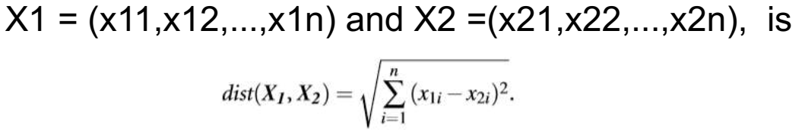
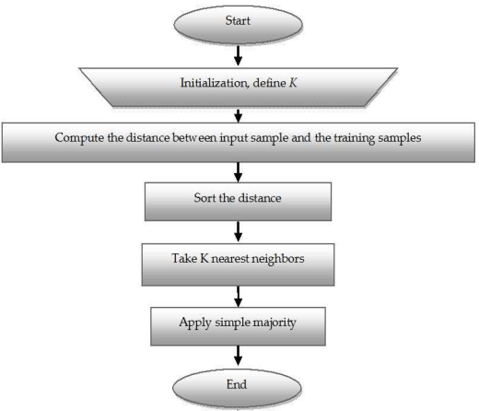
- Discussion about categorical attributes and missing values
  - How can distance be computed for attribute such as colour?
    - Simple Method:Compare corresponding value of attributes
    - Other Method: Differential grading
  - What about missing values:
    - If the value of a given attribute A is missing in tuple X1 and/or in tuple X2, we assume the maximum possible difference.
    - For categorical attributes, we take the difference value to be 1 if either one or both of the corresponding values of A are missing.
    - If A is numeric and missing from both tuples X1 and X2, then the difference is also taken to be 1.
- KNN algorithm – choosing distance measure and k
  - The k value that gives the minimum error rate may be selected
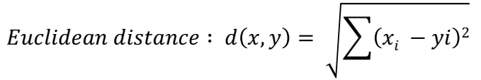
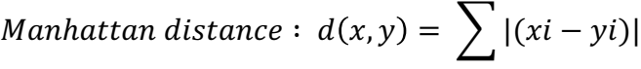
  - If infinite number of samples available, the larger is k, the better is classification
  - k = 1 is often used for efficiency, but sensitive to “noise”:

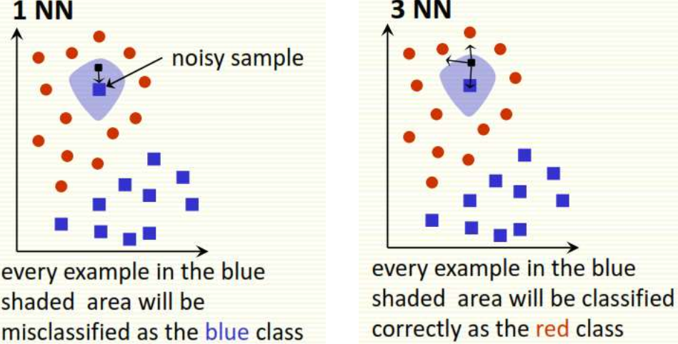

  - Larger k gives smoother boundaries, better for generalization, but only if locality is preserved. Locality is not preserved if end up looking at samples too far away, not from the same class
  - Interesting relation to find k for large sample data : k= sqrt(n)/2 where n is # of examples
  - Can choose k through cross-validation:

- Complexity of KNN
  - Basic kNN algorithm stores all examples
  - Suppose we have n examples each of dimension d
  - O(d) to compute distance to one examples
  - O(nd) to computed distances to all examples
  - Plus O(nk) time to find k closest examples
  - Total time: O(nk+nd)
  - Very expensive for a large number of samples
  - Very expensive for a large number of samples
- Advantages and disadvantages of KNN
  - Advantages of KNN
    - Can be applied to the data from any distribution for
example, data does not have to be separable with a
linear boundary
    - Very simple and intuitive
    - Good classification if the number of samples is large
enough
  - Disadvantages of KNN classifier
    - Choosing k may be tricky
    - Test stage is computationally expensive
    - No training stage, all the work is done during the test stage
    - This is actually the opposite of what we want. Usually we can afford training step to take a long time, but we want fast test step
- Applications of KNN Classifier
  - Used in classification
  - Used to get missing values
  - Used in pattern recognition
  - Used in gene expression
  - Used in protein-protein prediction
  - Used to get 3D structure of protein
  - Used to measure document similarity
- Bài tập
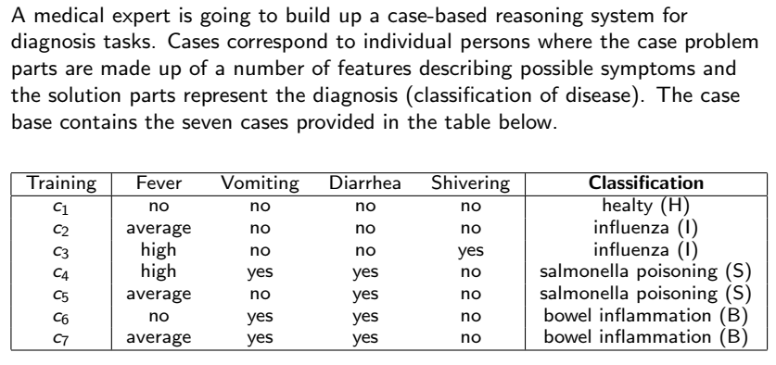
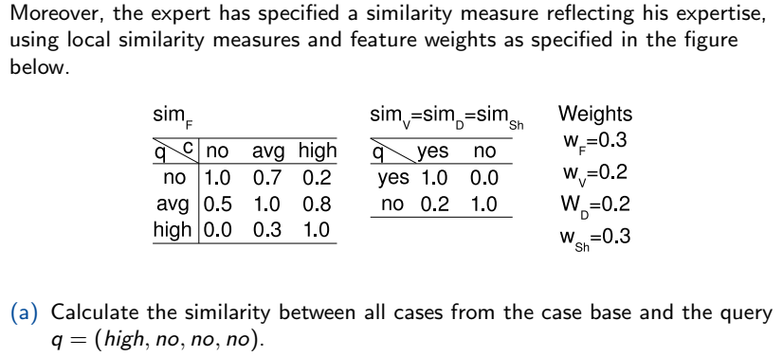
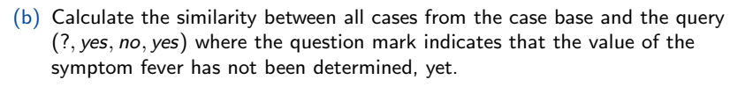
- Thực hành
Sử dụng Python dùng kNN cho các bài toán sau:
- Bài toán dự đoán về bệnh béo phì: Pima Indians Diabetes Database
- Bài toán dự báo ung thư vú: wisconsin-breast-cance
- Bài toán dự báo ung thư gan: Hepatitis Domain

Ngày 31 tháng 07 năm 2020
NGƯỜI BIÊN SOẠN

Trung tá, TS Trần Cao Trưởng

